Analyzing Bike Sharing Trends
The Bike Sharing dataset is available from the UCI Machine Learning Repository. It is one of the largest and probably also the longest standing online repository of datasets used in all sorts of studies and research from across the world. The dataset we will be utilizing is one such dataset from among hundreds available on the web site.
The dataset was donated by University of Porto, Portugal in 2013. More information is available at
https://archive.ics.uci.edu/ml/datasets/Bike+Sharing+Dataset

Data Set Information:
Bike sharing systems are new generation of traditional bike rentals where whole process from membership, rental and return back has become automatic. Through these systems, user is able to easily rent a bike from a particular position and return back at another position. Currently, there are about over 500 bike-sharing programs around the world which is composed of over 500 thousands bicycles. Today, there exists great interest in these systems due to their important role in traffic, environmental and health issues.
Apart from interesting real world applications of bike sharing systems, the characteristics of data being generated by these systems make them attractive for the research. Opposed to other transport services such as bus or subway, the duration of travel, departure and arrival position is explicitly recorded in these systems. This feature turns bike sharing system into a virtual sensor network that can be used for sensing mobility in the city. Hence, it is expected that most of important events in the city could be detected via monitoring these data.

Problem Statement
With environmental issues and health becoming trending topics, usage of bicycles as a mode of transportation has gained traction in recent years. To encourage bike usage, cities across the world have successfully rolled out bike sharing programs. Under such schemes, riders can rent bicycles using manual/ automated kiosks spread across the city for defined periods. In most cases, riders can pick up bikes from one location and return them to any other designated place.
The bike sharing platforms from across the world are hotspots of all sorts of data, ranging from travel time, start and end location, demographics of riders, and so on. This data along with alternate sources of information such as weather, traffic, terrain, and so on makes it an attractive proposition for different research areas.
The Capital Bike Sharing dataset contains information related to one such bike sharing program underway in Washington DC. Given this augmented (bike sharing details along with weather information) dataset, can we forecast bike rental demand for this program?

Attribute Information:
Both hour.csv and day.csv have the following fields, except hr which is not available in day.csv
- instant: record index
- dteday : date
- season : season (1:springer, 2:summer, 3:fall, 4:winter)
- yr : year (0: 2011, 1:2012)
- mnth : month ( 1 to 12)
- hr : hour (0 to 23)
- holiday : weather day is holiday or not (extracted from [Web Link])
- weekday : day of the week
- workingday : if day is neither weekend nor holiday is 1, otherwise is 0.
+ weathersit :
- 1: Clear, Few clouds, Partly cloudy, Partly cloudy
- 2: Mist + Cloudy, Mist + Broken clouds, Mist + Few clouds, Mist
- 3: Light Snow, Light Rain + Thunderstorm + Scattered clouds, Light Rain + Scattered clouds
- 4: Heavy Rain + Ice Pallets + Thunderstorm + Mist, Snow + Fog
- temp : Normalized temperature in Celsius. The values are derived via (t-t_min)/(t_max-t_min), t_min=-8, t_max=+39 (only in hourly scale)
- atemp: Normalized feeling temperature in Celsius. The values are derived via (t-t_min)/(t_max-t_min), t_min=-16, t_max=+50 (only in hourly scale)
- hum: Normalized humidity. The values are divided to 100 (max)
- windspeed: Normalized wind speed. The values are divided to 67 (max)
- casual: count of casual users
- registered: count of registered users
- cnt: count of total rental bikes including both casual and registered

Task:
- load the hour.csv and checking the shape of the loaded dataframe
- cleans up the attribute names to make them more understandable ['instant':'rec_id', 'dteday':'datetime', 'holiday':'is_holiday', 'workingday':'is_workingday', 'weathersit':'weather_condition', 'hum':'humidity', 'mnth':'month', 'cnt':'total_count', 'hr':'hour', 'yr':'year']
- perform type-casting of attributes using utilities like pd.to_datetime() and astype(). Convert hour_df['datetime'] to datetime, and season, is_holiday, weekday, weather_condition, is_workingday, month,year, hour to category type.
- visualize hourly ridership counts across the seasons and summarize the outcome
- visualize monthly ridership trends and summarize the outcome.
- visualize distribution of ridership across days of the week and summarize the outcome
- visualize monthly ridership trends and summarize the outcome(repeated)
- plots yearly distribution on violin plots and summarize the outcome
- visualize and analyze outliers for numeric attributes like total_count, temperature, and wind_speed, similarly try to check outliers at different granularity levels like hourly, monthly,
- prepares a correlational matrix on given dataset
- Since the dataset contains multiple categorical variables, it is imperative that we should encode the nominal ones(categorical columns)
- Start linear regression modeling our Bike Sharing dataset and solve the business problem of predicting bike demand for a given date time
- Generate scatter plot between residuals and observed values

Figure: 1: Season wise hourly distribution of mean of total counts
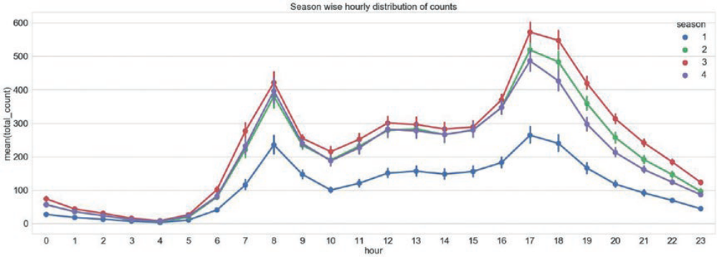

Figure: 2 :Weekdays wise hourly distribution of mean of total counts

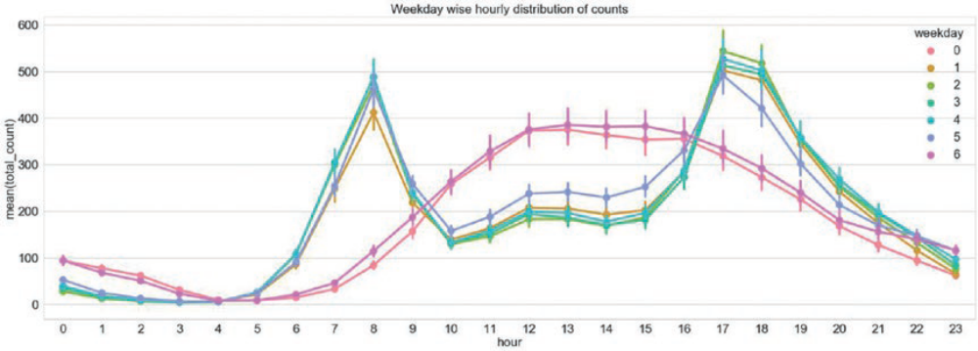
Figure 3: Trend in ridership based on month of the year

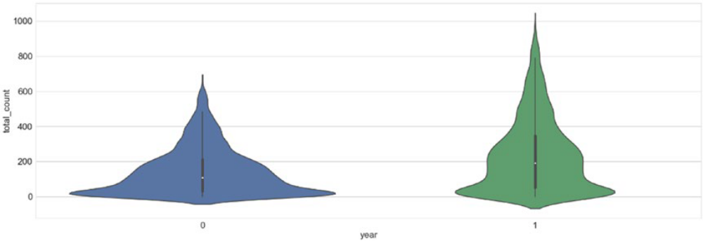
Figure 4: outliers for numeric attributes like total_count, temperature, and wind_speed
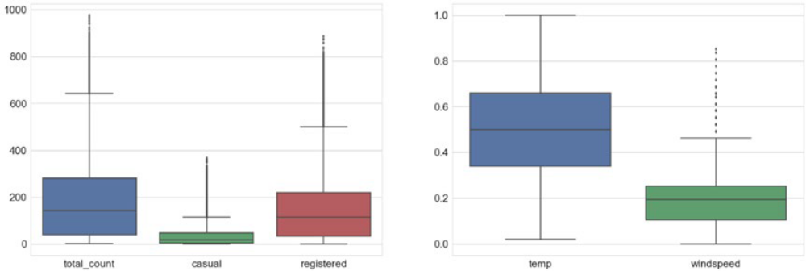
Figure 5: Outliers at different granularity levels like hourly, monthly
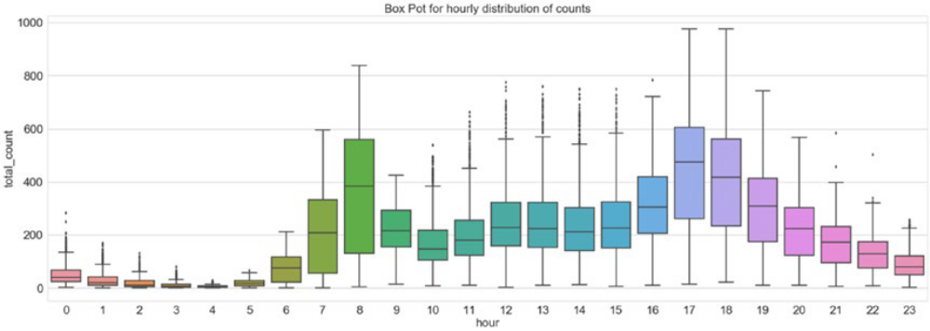
Figure 6: Correlational matrix
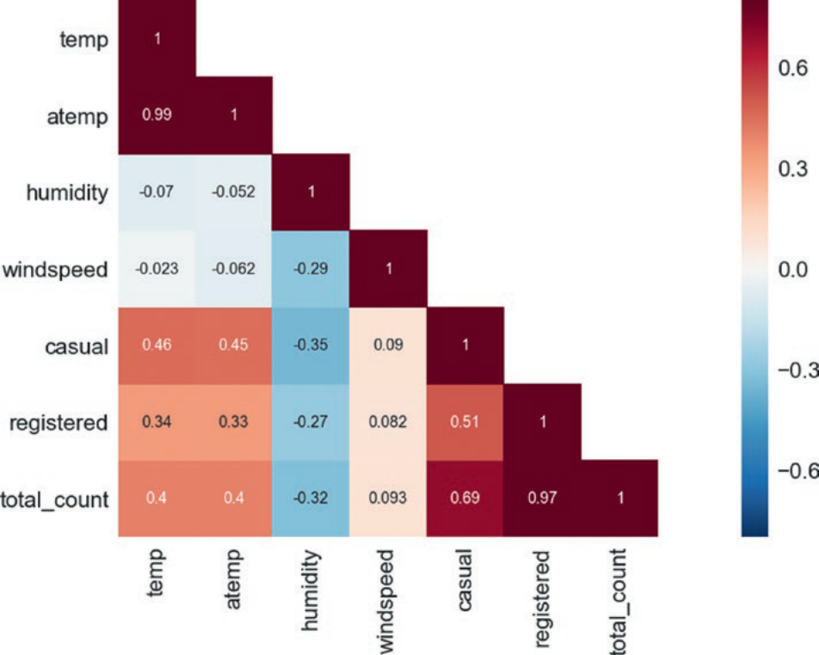
Figure 7: Residual Analysis
